# Trapezoidal Distribution

**Consider a trapezoidal PDF with parameters 0 ≤ *a* ≤ *c*1 ≤ *c*2 ≤ *b* for the minimum value *a*, maximum value *b*, and transition points *c*1 and *c*2 between linear and constant segments:**

|  |  |  |  |  |
| --- | --- | --- | --- | --- |
|  |  |  |  |  |
|  |  |  |  |  |

***h***

*f* (*y*)

**0**

*a c c*

**0 1 2 *b***

***y***

* + 1. **Using the property $\int_{a}^{b}{f (y)dy = 1}$, solve for *h* in terms of *a*, *b*, *c1*, and *c2*.**

**(*Hint:* write an equation for the area under the PDF, set equal to 1, and solve for *h*.)**

* We know that:

$\int_{-∞}^{∞}{f\left(x\right)dx}=1$ and it is given that $\int_{a}^{b}{f(y)}dy=1$

Area of trapezoid is: $\frac{Sum of parallel sides}{2}x height$

Therefore.

🡪 🡪

* + 1. **Write an equation for the PDF *f* (*y*) in terms of *a*, *b*, *c*1 and *c*2 for the ranges:**
       1. ***a < y* ≤ *c*1 (*Hint:* verify *f* (*a*) = 0 and *f* (*c*1) = *h*.)**
* f (y) = [formula of ramp equation]

Substituting value of h in this equation, we get

* + - 1. ***c*1 *< y* ≤ *c*2**

=

* + - 1. ***c*2 *< y* ≤ *b* (*Hint:* verify *f* (*c*2) = *h* and *f* (*b*) = 0.)**

=

* + 1. **Write an equation for the CDF *F* (*y*) in terms of *a*, *b*, *c*1 and *c*2 for the ranges:**
       1. ***a < y* ≤ *c*1 (*Hint:* the area of the triangular region between *a* and *y*.)**

=

* + - 1. ***c*1 *< y* ≤ *c*2 (*Hint: F* (*c*1) plus the area of rectangular region between *c*1 and *y*.)**

* + - 1. ***c*2 *< y* ≤ *b* (*Hint: F* (*c*2) plus the area of triangular region between *c*2 and *y*.)**
    1. **Draw a sketch of the CDF *F* (*y*) for parameters *a* = 0*.*5*, c*1 = 1*.*5*, c*2 = 2*.*5*, b* = 3*.*5.**

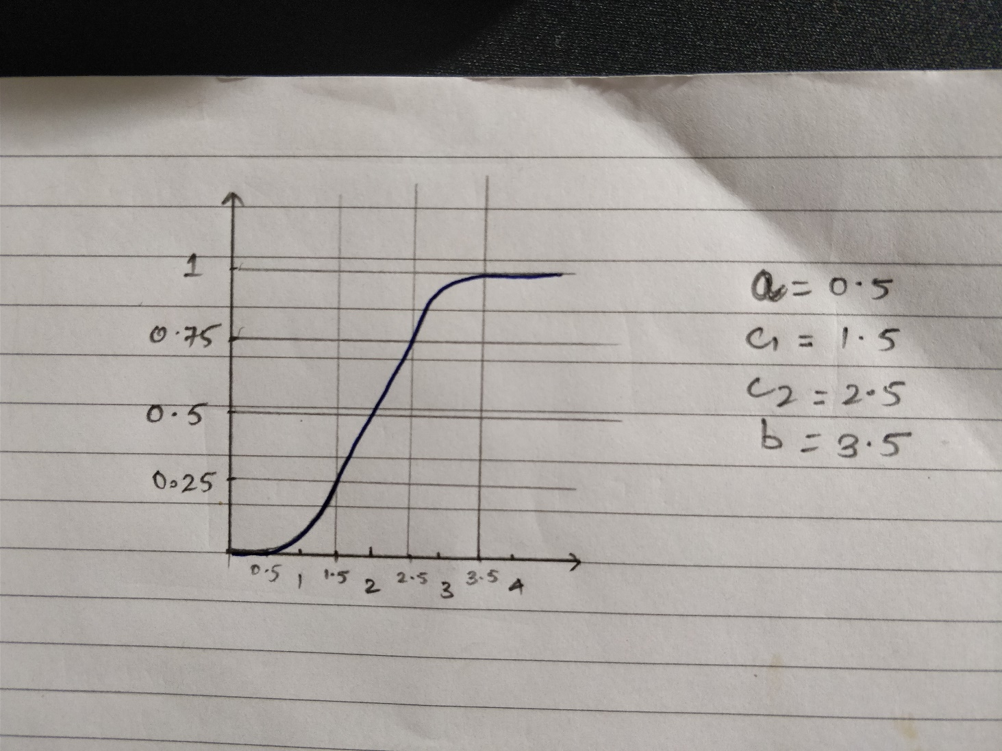

Figure CDF plot

|  |  |
| --- | --- |
| **Y** | **F(y)** |
| 0 | 0 |
| 1.5 | 0.25 |
| 2.5 | 0.75 |
| 3.5 | 1 |
| 4 | 1 |

Table CDF Values

# Caf´e Java: Customer Inter-arrival

**Mathematically inclined customers arrive at Caf´e Java following a Poisson process:**

* **There is a long-term average rate of *λ* = 2 customer arrivals per minute.0.**
* **The arrival rate is constant throughout the day.**
* **Customer arrivals are independent of each other.**

**Under these assumptions, the inter-arrival time between customers is an exponentially- distributed random variable *X* with *rate* parameter *λ*1:**

***X* ∼ exponential (*λ*)**

* + 1. **Write an equation for the PDF *f* (*x*).**
* λ = $\frac{1}{2}$ customer per minute [inter arrival rate]

∴

* + 1. **Draw a sketch of the PDF *f* (*x*) for 0 ≤ *x* ≤ 5.**

Graph PDF of x

* + 1. **Find the population mean *µ* = *E* [*X*] and mark on the PDF plot.**
* Mean μ =

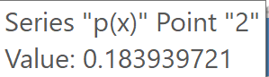

Graph Mean value in p(x)

* + 1. **Write an equation for the CDF *F* (*x*).**
 $F\left(x\right)={1-e}^{-0.5x}$

   2. **Draw a sketch of the CDF *F* (*x*) for 0 ≤ *x* ≤ 5.**

Graph CDF of x

* + 1. **Evaluate or estimate the following quantities and mark on the CDF plot:**
       1. **10th percentile inter-arrival time *P*10 (*Hint* : *F* (*P*10) = 0*.*10)**
       2. **Median inter-arrival time *P*50 (*Hint* : *F* (*P*50) = 0*.*50)**
       3. **90th percentile inter-arrival time *P*90 (*Hint* : *F* (*P*90) = 0*.*90)**